**Portfolio Project – Digital Nose by Igor & Hazel**

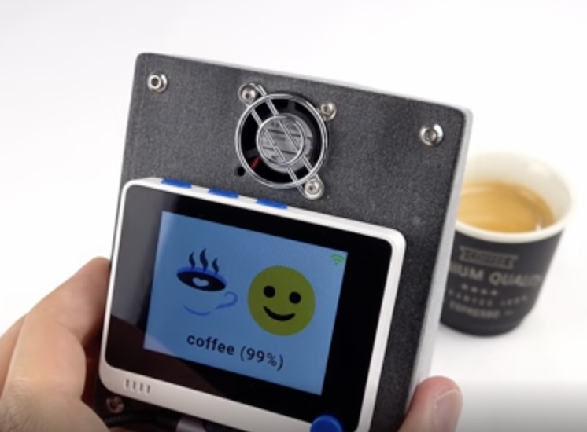

# Supervised machine learning & Classification Problem:

* Feature extraction: Extracts smell
* Establish the correlation to train the model: Given the smell, expect the answer
  + Find out the concentration of each gas at given time interval (e.g. 1.5 seconds)

# Model:

Fully-connected Neural Network (see chart1 below)

Graphical User Interface (GUI)

Real-time telemetry: connect the Wio Terminal to Wifi firmware, IoT Hub

# Use case:

Preliminary: Identify 50 classes of smells

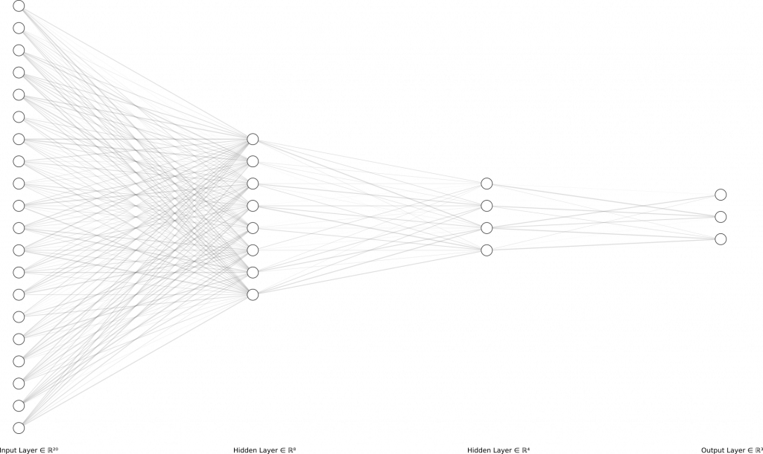

# Elements to be measured:

- Nitrogen dioxide (NO2)

- Carbon monoxide (CO)

- Ethyl alcohol (C2H5OH)

- Volatile organic compounds (VOCs)

# Questions (to be discussed):

1. Once the model has been trained, rely on Cloud? Or only sensor data (offline device)
2. Categories: How many? Currently, e.g. starts with 50 categories with 1000 samples each. e.g. new-car smell, cigarette smoke to raspberries, coffee, diesel, Strawberry, cheese, fish etc

# Further development: (possible future developments)

E.g. 1 Checking on health

Morning: blow into the sensor (watch).

* Your diabetic level is not so good today
* Your oxygen level is not good. Pre-detect Pneumonia / Bronchitis
* You are highly stressed

E.g. 2 Checking on water cleanliness. In Germany, Calsium (kalt) is built up on water from tap and if it is not filtered , it is accumulated and affects the taste of tea to be produced.

E.g. 3 Cleaning company:

- Instead of having janitor that goes to clean the office area once per day regularly no matter what, he/she will clean unnecessarily. Clean the necessary area instead.

E.g. 4 Helping coffee makers refine the perfect cup. Past difficulties: Extreme difficult to characterise coffee powder e.g. How to identify the qualify before it is brewed?

E.g. 5 - sniffing out fuel leaks and engine problems in cars before it poses serious threat to the driver

E.g. 6 Integration with Smart kitchen appliances to become ‘Automated kitchen assistant’; Oven that automatically detects the bread is done and turn off itself (instead of human manual adjustment)

E.g. 7 A sensor in fridge that spot spoiled food, COVID patience who lost taste bud. Binding odor molecules to biosensors

* Trigger rules (e.g., bad smell, rotten food, spoiled milk)

E.g. 8 Burger flipping robot - additional quality checking on top of AI technology

* 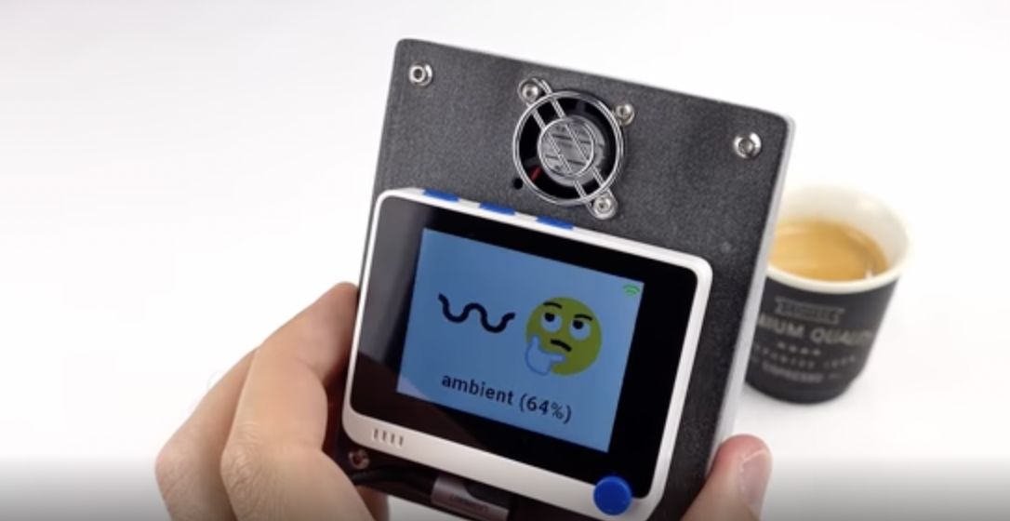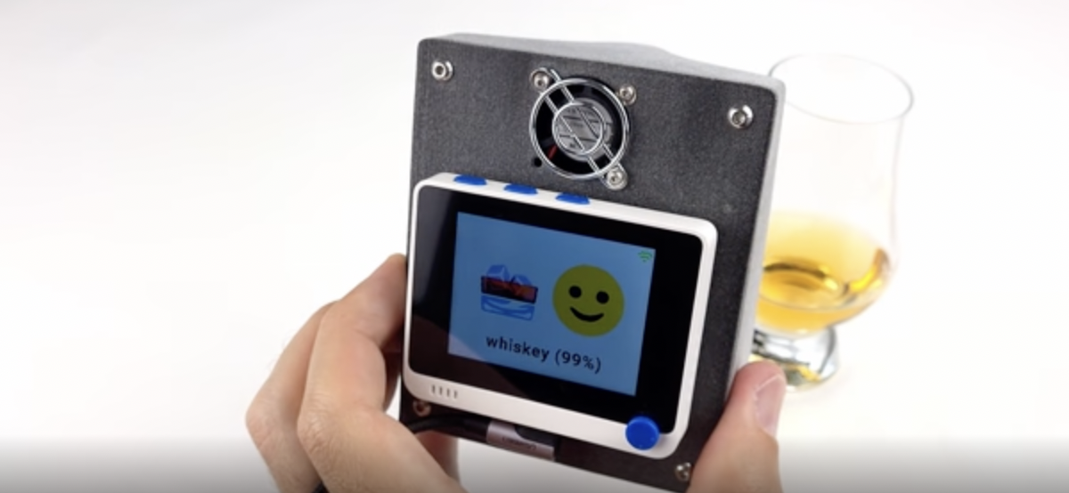

Credit: <https://blog.benjamin-cabe.com/2021/08/03/how-i-built-a-connected-artificial-nose#comments>